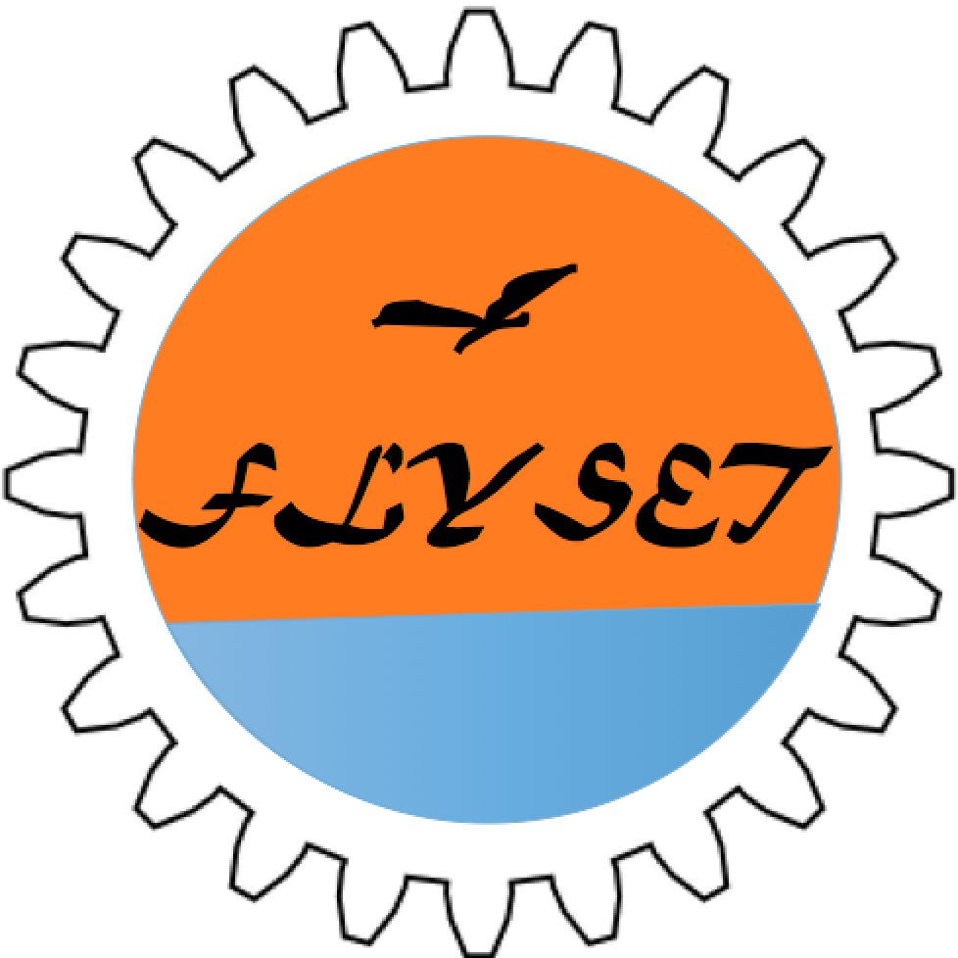
FTC Team Workshop for the New Platform

When: August 29th, 2015
Who: FTC teams and coaches
Where: QD Academy, 4100 Legacy Drive, Suite 404, Plano, 75024
Registration: Free. Register at

FTYSET.org and affiliated FTC team 8565 (TechnicBots) are hosting an FTC team workshop to help local FTC teams get acquainted with the new Android Technology platform and create an environment for FTC teams to share and learn. The workshop is going to be held on 8/29/2015, just in time before the next season Challenge to be released on 9/12/2015.

Workshop Agenda:

9:00am: Keynote speaker

9:30am-12:00pm: Sessions on hardware, debugging and software. Three different kinds of robots will be used throughout sessions: FTC competition Robot with new motor/servo controllers and sensor module, K9Robot which can be driven with the Robot Controller / Driver Station apps downloaded from Google Play store and a Sparring robot with legacy module and legacy motor controllers.

12:00pm-1:00pm: lunch break

1:00pm-3:00pm: Track #1: Team sharing sessions (15 minute each). While registering on the website, each team can propose a topic they would like to share or topics they would like to learn which will be published on the registration website for other teams to sign up to present if they know the topic

1:00pm-3:00pm: Track #2 - On field test with last season's field and Robot The robots will use new Android technology to experience the new competition format in a friendly environment

There will also be a station available in the afternoon where crimping tools and Anderson Connectors are provided for the teams to make their DC motor and legacy controller power wires compatible with Anderson connectors so they can connect to the new motor controllers.
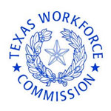
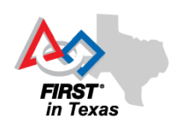
Sponsors:

